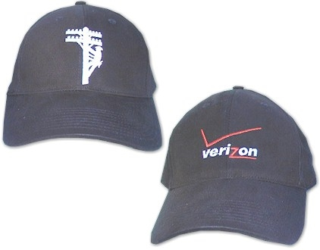
Black Verizon or Lineman logo caps | Quantity:  Item# VZ/VZCap  Price $16.00  (Verizon logo)
Quantity:
Item# VZ/Linemancap
Price $16.00
(Lineman logo)

Quantity:
Item# VZ/2CapCombo
Price $27.00
(2 cap combo)

Volunteer this season wearing your choice of the Verizon or the Lineman logo embroidered caps.
These black "Nike style" caps are 100% cotton with an adjustable velcro strap and a formed brim.
Just $27 for the combination Lineman - Verizon set. Appropriate
shipping charges will be added to all cap purchases.

Style | Quantity
Lineman Cap | 5
Verizon Cap | 26

